UST DEPEG RISK

# What is Terra?

Terra is a decentralized financial payment network that rebuilds the traditional payment stack on the blockchain. It utilizes a basket of fiat-pegged stablecoins, algorithmically stabilized by its reserve currency LUNA, to facilitate programmable payments and open financial infrastructure development.

# What Problems Does Terra (LUNA) Solve?

Terra seeks to alleviate many issues currently faced by the world’s top stablecoins. For one, the network wants to reduce centralization in the market. Unlike the competition, Terra’s protocol functions across multiple blockchains. The network also seeks to remove technical limitations on these assets through its open financial infrastructure.

# How Does Terra (LUNA) Work

Terra utilizes a programmable infrastructure to provide the market with self-stabilizing stablecoins and other unique features. To accomplish this task, the network relies on an elastic monetary supply mechanism. The platform automatically adjusts the supply of its stablecoins to ensure that their values remained pegged to their underlying assets.

# Stablecoins

There are many different types of Stablecoins available on Terra at this time. Specifically, you can access TerraUSD (UST) which is pegged to the U.S. dollar, TerraKRW (KRT) which is pegged to the South Korean won, TerraMNT which is pegged to the Mongolian tugrik, and TerraSDR (SDT), which is pegged to the IMF’s SDR unit of account.

# Maintaining The Peg

UST and LUNA are both dependent on each other since the acceptance of the Terra ecosystem is a combination of UST adoption and LUNA demand.

LUNA is the native token of the Terra ecosystem yielding governance and staking benefits. It also acts as an asset reserve that absorbs the volatility of UST through the protocol’s algorithmic market module.

UST is the stable token of the Terra ecosystem meant to have the price pegged to 1 USD so that users can use a digital form of fiat currency with the blockchain’s added benefits.

Terra’s market module enables users to always trade 1 USD worth of LUNA for 1 UST and vice versa, incentivizing arbitrage traders to maintain the price of UST during periods of expansion or contraction of UST demand

Example

If 1 UST trades above peg at $1.01, then any user can buy $1 worth of LUNA and burn it in order to mint 1 UST. The user can then market sell that 1 UST for $1.01, yielding a $0.01 profit.

## Illustration

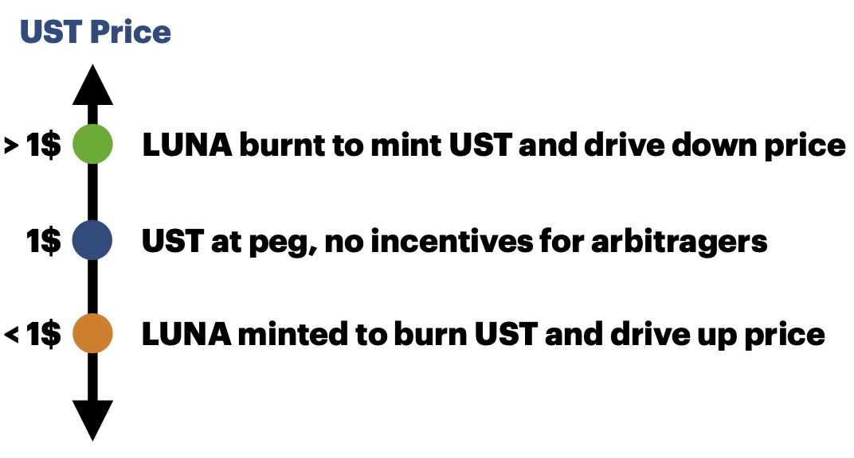

If 1 UST trades below peg at $0.99, then any user can buy 1 UST for $0.99 and mint $1 worth of LUNA. The user can then market sell the $1 worth of LUNA, yielding a $0.01 profit.

UST De-Pegging Risks

UST can temporarily break its peg during volatile market in primarily two conditions and in an additional worst-case-scenario.

## 1.) The LUNA burning and minting cap is met.

The Terra ecosystem has a set of liquidity parameters meant to control the amount of LUNA that can be burned and minted on a daily basis. If the price of UST rises or falls enough to require more minting or burning of LUNA than the cap allows in a single day, then the ability for arbitragers to keep the peg is restricted. This would temporarily de-peg UST while arbitragers wait until the next day to mint or burn LUNA and bring UST back to peg.

Currently the LUNA minting and burning cap is set at about $135 million worth of LUNA daily. This cap is determined via governance voting of LUNA holders.

The reason a LUNA minting and burning cap is put in place is to prevent oracle attacks where a large LUNA holder could manipulate on-chain and off-chain market pairs.

This attack on the on-chain market can be done as follows:

1. Attacker bids off-chain reference markets up heavily by buying LUNA on-chain.
2. Oracles read off-chain prices and report higher LUNA prices.
3. Attacker sells a ton of LUNA for UST on-chain.
4. Attacker sells off-chain LUNA acquired in step 1.
5. Attacker buys a ton of on-chain LUNA with the extra UST they got from step3. They end up with more LUNA on-chain and the roughly the same amount of LUNA off-chain, giving them a net profit.
6. Attacker can repeat this and dilute LUNA holders who trade LUNA on whatever the price oracles report on-chain.

# Example and Illustration:

**\* Assume 1 LUNA = 10 UST**

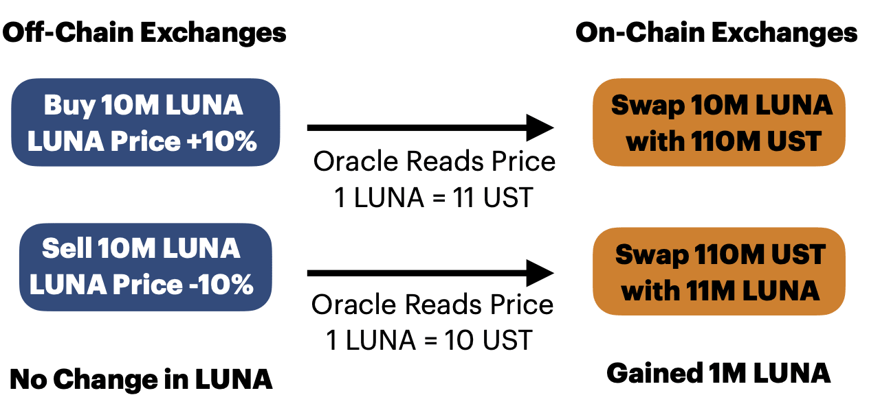

With a cap on the amount LUNA that can be minted or burned, the amount made by the attacker would not exceed the fees and slippage incurred to attempt to bid the price up on off-chain exchanges that the oracle price reads from.

As the market cap of UST and LUNA increase, this parameter will need to be adjusted to be able to absorb a greater supply of UST and its price fluctuations. It will also still need to account for potential attacks on LUNA oracles. Proposal 3895, made in January, asked LUNA governance holders to vote for an increase of the on-chain liquidity parameter cap from $135 million to $293 million worth of LUNA daily.

# 2.) LUNA and UST “Death spiral”

A death spiral occurs when a loss of demand for UST causes more LUNA to be minted, reducing LUNA’s price which causes more LUNA selling, which then panics people into selling more UST.

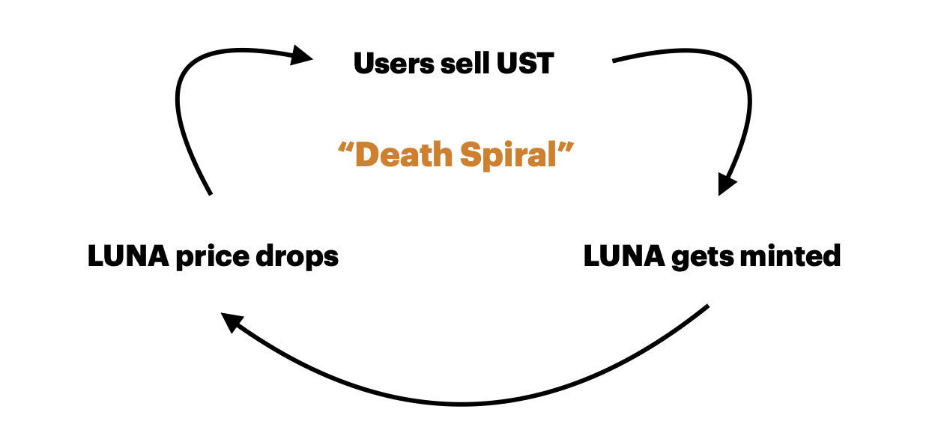

This situation turns into a bank run onto the Terra ecosystem and it will make it harder for arbitragers to turn a profit when minting LUNA and burning UST. This would be constraining the rate at which UST price adjusts, causing it to de-peg in extreme scenarios.

***Recent Update: The Luna Reserve Guard (LFG) recently announced arbitragers could burn UST for BTC in the event minting LUNA no longer becomes profitable. This would minimize the risk of UST de-pegging in the event of a “bank run” on the Terra ecosystem.***

## 3.) Liquidity and slippage issues when market selling LUNA or UST.

The UST peg relies on arbitragers to mint and burn LUNA. Most arbitrage trades are done programmatically and only execute if they can then sell or buy LUNA without incurring costs exceeding the profit they would make. When liquidity pool providers withdraw liquidity from decentralized platforms, it raises the slippage or cost taken in order to make a trade. This raises the threshold in price discrepancy needed for arbitragers to make profit on a trade. So, liquidity issues can bottleneck the rate at which UST returns to peg and thus contribute to UST de-pegging.

It is important to stress that there is no liquidity issues when minting or burning LUNA itself. This can be done as quickly as needed as long as it does not exceed the cap described in scenario 1. Scenario 2 speaks on when arbitragers then dump UST or LUNA in decentralized exchange swaps like Astroport to finalize their arbitrage trade.

## History of UST Losing its Peg

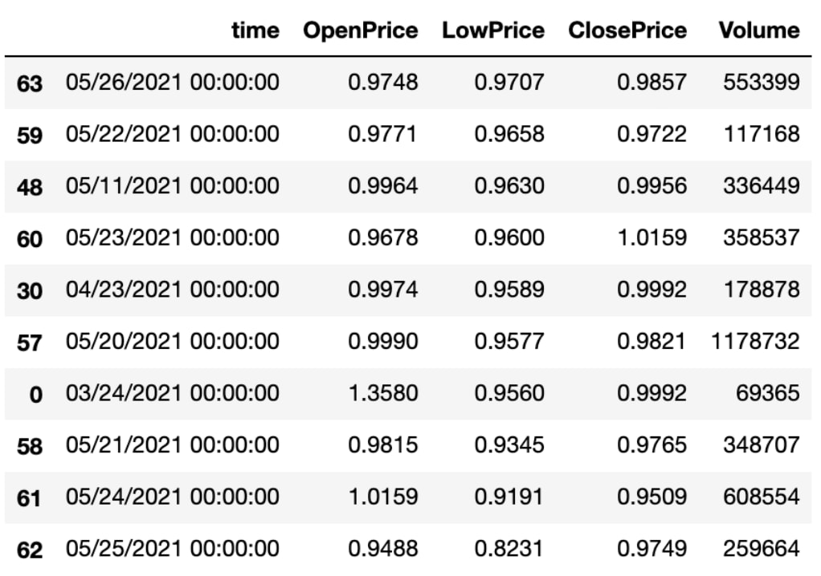**\*UST/USDT Daily Candles on gate.io Top 10 UST de-pegs in 2021**

UST has fallen below 90 cents before in times of extreme volatility and volume on a few occasions in 2021. In May of 2021, the max amount of minting and burning of LUNA was met, leading to 6+ days of UST being below peg. This was partly due to the liquidity parameters not being updated in time to account for the greater trading volume of LUNA. Proposal 1175 was then made shortly after this event recommending an increase to the cap in order to bring UST back to peg quicker.

Do not always expect UST to remain at peg, so for those leveraging their positions, do keep in mind that it is possible for UST to dip to the low 90s cent range for a short period, which is enough for many to be liquidated during that time.

## Supply Change Relationship Between LUNA and UST

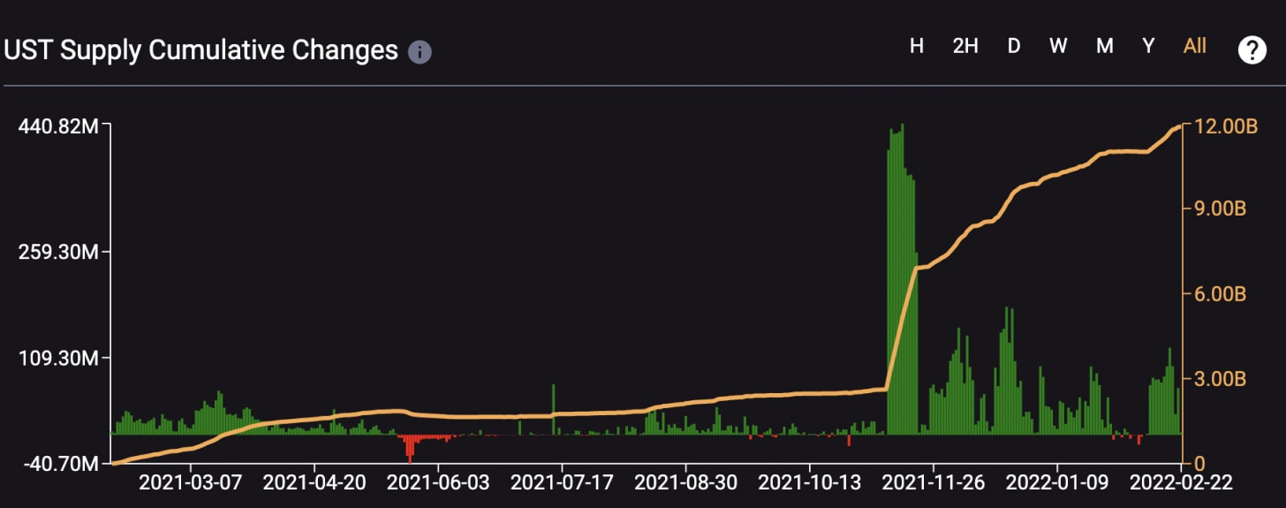

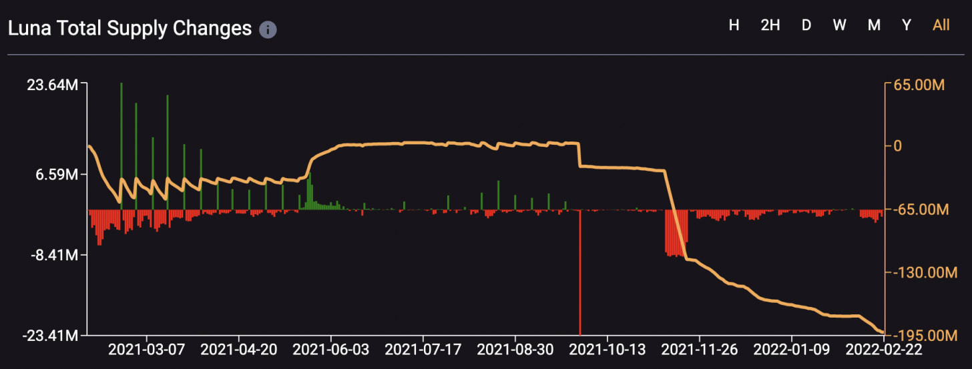

**Total Supply Changes of LUNA and UST from 03/2021 - 03/2022 (**[terra.smartstake.io](http://terra.smartstake.io/))

The green regions show that during periods of UST adoption, where UST supply is increased, LUNA is burned making its total supply decrease. The green region also occurred shortly after the Columbus-5 update, which enabled more functionality on the Terra blockchain and encouraged more users to use UST as a stablecoin option.

The red region shows that during UST contraction, where UST supply is decreased due to low demand, LUNA supply is increased to absorb this.

## Terra Ecosystem Feedback Loop

LUNA and UST work together to provide stability and ownership in the Terra ecosystem. LUNA holds the benefit of governance and value, which increases as Terra UST adoption increases. UST holds the benefit of stability within the Terra ecosystem. During periods of decline, LUNA helps UST maintain peg with its inherent value, but during periods of adoption, LUNA holders have an increased benefit due to LUNA being burned.

This symbiotic relationship between Terra USD and LUNA is much like the relationship between the Earth (Terra) and the Moon (Luna), hence where the names are derived from. Luna stabilizes Terra UST’s orbit (price).

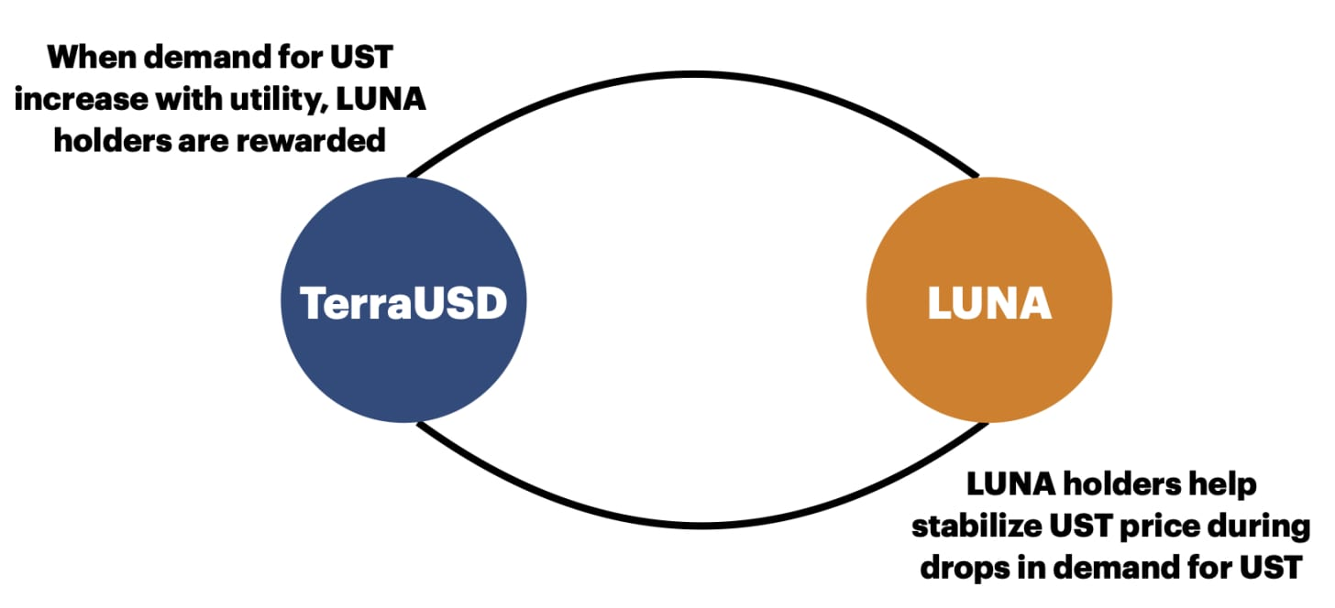

This means that an increase in UST utility rewards LUNA holders since they hold the risk of stabilizing UST by increasing LUNA supply. A feedback loop occurs on Terra because LUNA promotes the use of UST and UST adoption increases the value of LUNA.

One of the biggest drivers of UST adoption is Anchor protocol, which rewards holders of UST a 20% yield. As of February 2022, the total value locked (TVL) on Anchor protocol is over $8.7 billion. There are dozens more of protocols that promote UST utility, making Terra a great ecosystem to interact with.